CHAPTER 3: Cells
Worksheet 3.2

In focus
Answers
Microscope
In order to zoom in on the units of life, you first need to be able to focus. Add labels to the diagram below.
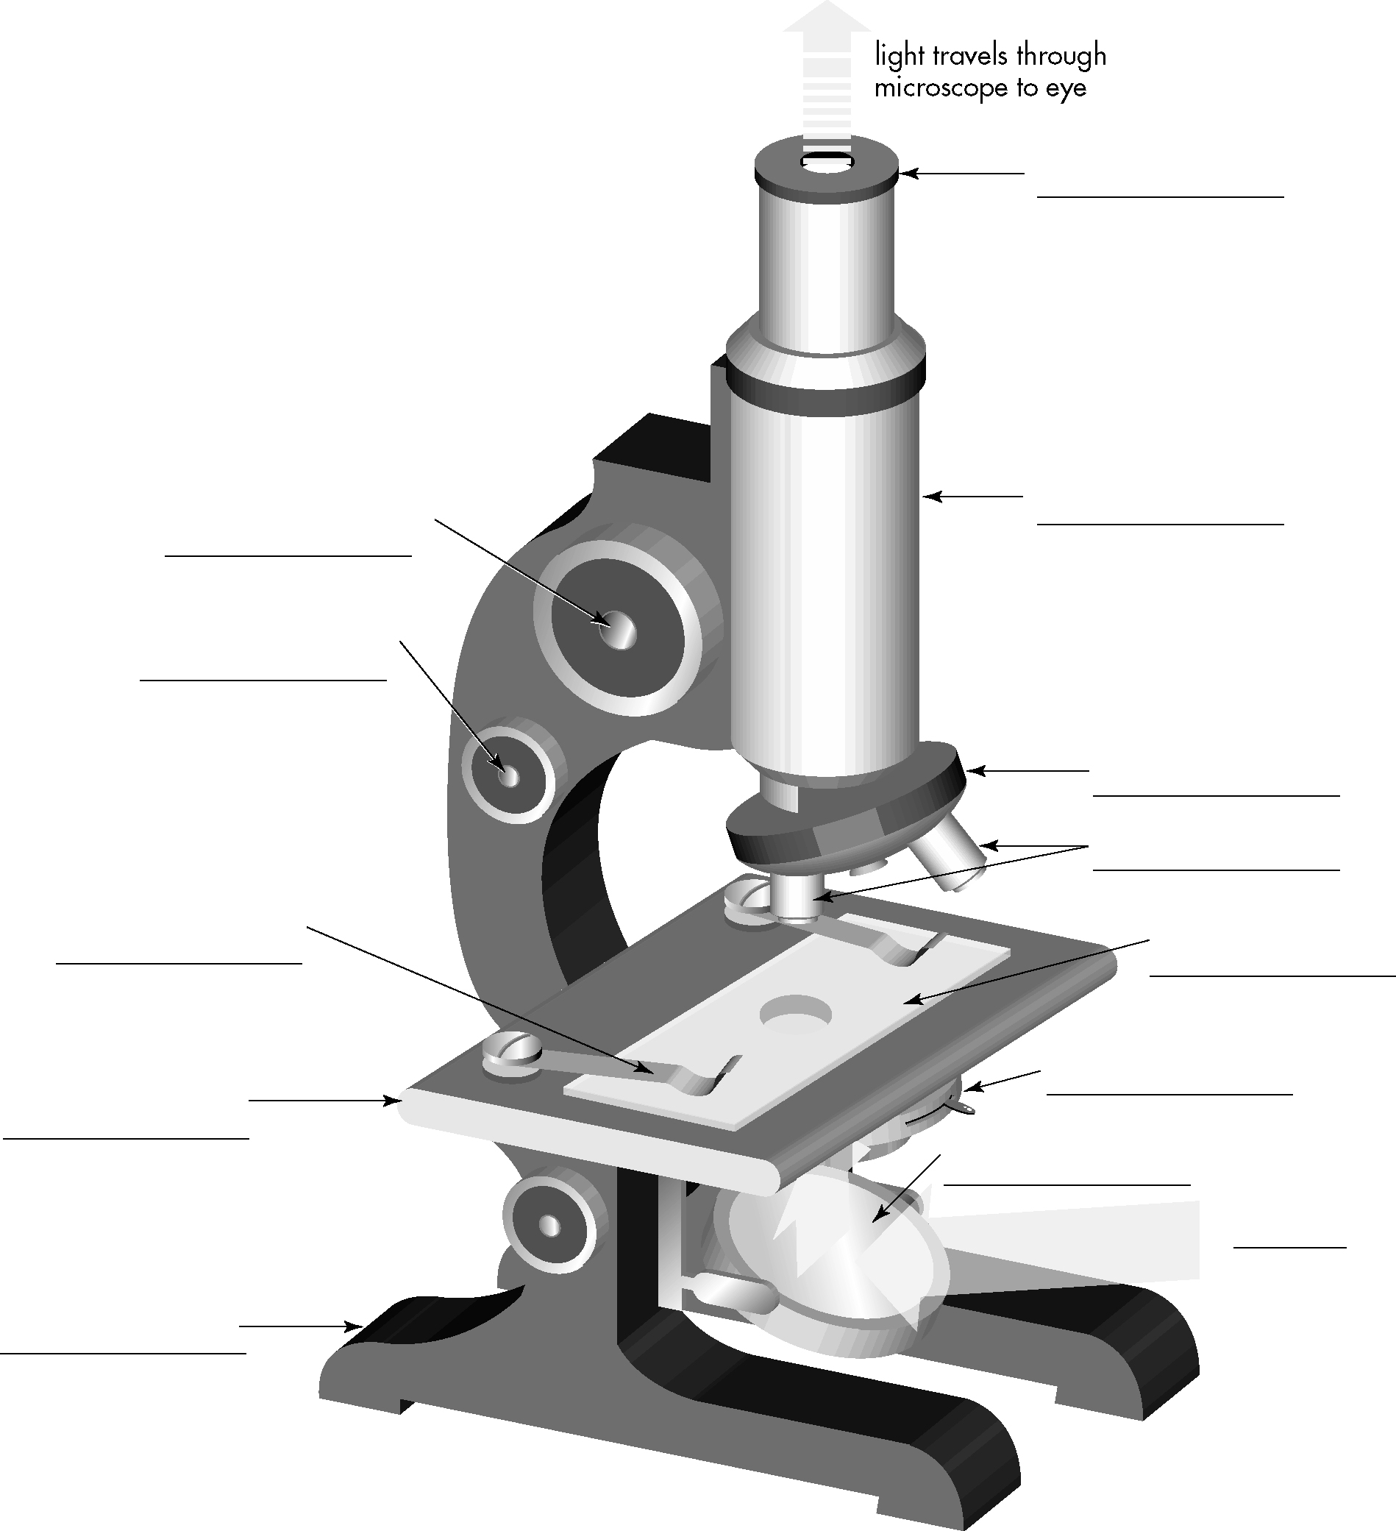
Base
Stage
Stage slide clip
Fine focus knob
Coarse focus knob
Slide
Iris adjustment
Mirror
Light
Objective lens
Revolving nosepiece
Body tube
Eyepiece lens (ocular)
Important reminders when using a microscope
1. When lifting the microscope, put one hand on the body of the microscope and one hand under its base .
2. The microscope should be used on a bench and not too close to the edge.
3. Take care that the light intensity is not too high, or it might damage your eye.
4. Return the shortest objective lens into position when finished.
5. Remove the dust cover , and ensure that the stage is clean.
6. Make sure that, when your microscope is not in use, it is always clean and carefully put away.

